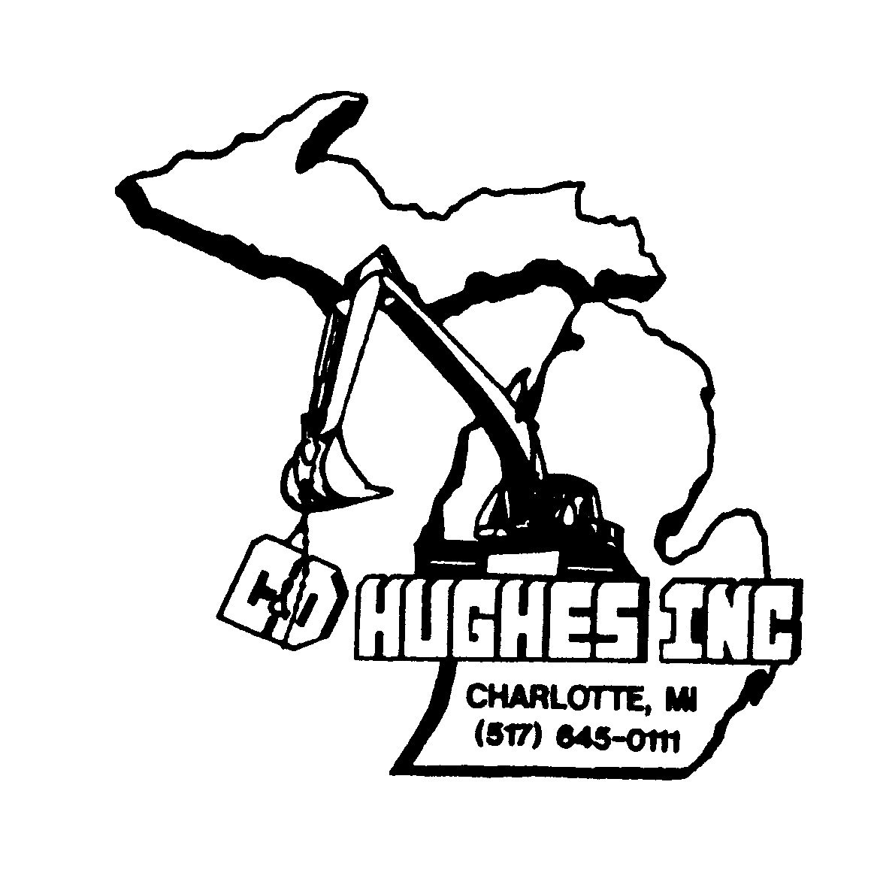**C & D HUGHES, INC.**

# 3097 Lansing Road Charlotte, MI 48813

(517) 645-0111 Fax: (517) 645-0090

MDOT Prequalified Heavy Highway Construction and Maintenance Divisions: Milling, Asphalt, Joint Repair, Concrete, Dirt & Pipe

# COVID-19 Preparedness & Response Plan

# **For Lower and Medium Exposure Risk Employers ONLY**

 **General**

The following COVID-19 preparedness & response plan has been established for C & D Hughes, Inc. in accordance with MIOSHA Emergency Rules for Coronavirus disease 2019 (COVID-19). The purpose of this plan is to minimize or eliminate employee exposure to SARS-CoV-2.

The Emergency Rules have general safeguards applicable for all workplaces and specific safeguards for certain industries. Sherry VanPatten has read these emergency rules carefully, developed the safeguards appropriate to C & D Hughes, Inc. based on its type of business or operation, and has incorporated those safeguards into this COVID-19 preparedness and response plan.

C & D Hughes, Inc. has designated one or more worksites supervisors to implement, monitor, and report on the COVID-19 control strategies developed in this plan. The worksite supervisor(s) will remain on-site at all times when employees are present on site. An on-site employee may be designated to perform the supervisory role.

The plan will be made readily available to our employees and their representatives. The plan will be made available via C & D Hughes, Inc. website and/or hard copy at the office..

 **Exposure Determination**

C & D Hughes, Inc. has evaluated routine and reasonably anticipated tasks and procedures for all employees to determine whether there is actual or reasonably anticipated employee exposure to SARS-CoV-2.

C & D Hughes, Inc. has determined that its employees' jobs fall into only the lower exposure and medium exposure risk categories as defined by the OSHA Guidance on Preparing Workplaces for COVID-19:

■ **Lower Exposure Risk Jobs**. These jobs do not require contact with known or suspected cases of COVID-19 nor frequent close contact (for example, within six feet) with the general public. Workers in this category have minimal occupational contact with the public and other coworkers. Examples are small offices, small manufacturing plants (less than 10 employees), small construction operations (less than 10 employees), and low-volume retail establishments, provided employees have infrequent close contact with coworkers and the public.

■ **Medium Exposure Risk Jobs**. These jobs are those that require frequent or close contact (for example, within six feet) with people who may be infected with SARS-CoV-2, but who are not known or suspected COVID-19 patients. Examples are most jobs at manufacturing plants, construction sites, schools, high-volume retail settings, and other high-population-density work environments.

Sherry VanPatten verifies that C & D Hughes, Inc. has no high-risk exposure jobs. High exposure risk jobs have high potential for exposure to known and suspected cases of COVID-19. Examples are most jobs in healthcare, medical transport, nursing homes and residential care facilities, mortuaries, law enforcement, and correctional facilities. This sample plan is not intended for employers who have high exposure risk jobs.

 **Engineering Controls**

C & D Hughes, Inc. has implemented feasible engineering controls to minimize or eliminate employee exposure to SARS-CoV-2. Engineering controls involve isolating employees from work-related hazards using ventilation and other engineered solutions. In workplaces where they are appropriate, these types of controls reduce exposure to hazards without relying on worker behavior and can be the most cost-effective solution to implement.

For lower exposure risk jobs, new engineering controls are not required. For medium exposure risk jobs, engineering controls can include:

■ Installing physical barriers (such as clear plastic sneeze guards) between coworkers or between workers and customers.

■ Installing a drive-through window for customer service.

■ Increasing the amount of ventilation in the building.

■ Increasing the amount of fresh outdoor air that is introduced into the building.

Cheryl Hughes, President will be responsible for seeing that the correct engineering controls are chosen, installed, maintained for effectiveness, and serviced when necessary.

 **Administrative Controls**

Administrative controls are workplace policies, procedures, and practices that minimize or eliminate employee exposure to the hazard. Cheryl Hughes, President will be responsible for seeing that the correct administrative controls are chosen, implemented and maintained for effectiveness.

(Choose the controls below that are feasible for your workplace. Delete the controls that are not feasible or applicable. Add additional rows for other feasible administrative controls that will be implemented. In the first column, indicate which jobs or tasks will use each administrative control.)

|  |  |
| --- | --- |
| **Job/Task** | **Administrative Control**  **(For Example, Workplace Distancing, Remote Work, Notifying Customers)** |
| All employees | Maintain at least six feet from everyone on the worksite. |
| X | Use ground markings, signs, and physical barriers to prompt employees to remain six feet from others. |
| X | Promote remote work (telecommuting) to the fullest extent possible. |
| X | Restrict face-to-face meetings. Communicate with others through phone, email, teleconferencing, and web conferencing. |
| X | Minimize the sharing of tools, equipment, and items. |
| X | Provide employees with non-medical grade face coverings (cloth face coverings). |
| X | Require employees to wear cloth face coverings when they cannot consistently maintain six feet of separation from other individuals in the workplace. |
| X | Require customers and the public to wear cloth face coverings. |
| X | Encourage proper cough and sneeze etiquette by employees, including covering coughs and sneezes and coughing and sneezing in one’s elbows rather than hands. |
| X | Ensure that sick leave policies are flexible and consistent with public health guidance, so employees do not go to work sick. |

* **Hand Hygiene**

Sherry VanPatten, COVID Coordinator will be responsible for seeing that adequate handwashing facilities are available in the workplace and that regular handwashing is required. Frequency of such handwashing will be determined in part by factors such as when and how often the employees’ hands are potentially exposed to SARS-CoV-2. When handwashing facilities are not available,

C & D Hughes, Inc. shall provide employees with antiseptic hand sanitizers or towelettes. C & D Hughes, Inc. will provide time for employees to wash hands frequently and to use hand sanitizer.

C & D Hughes, Inc. shall promote frequent and thorough hand washing, including by providing workers, customers, and worksite visitors with a place to wash their hands. If soap and running water are not immediately available, provide antiseptic hand sanitizers or alcohol-based hand towelettes containing at least 60 percent alcohol.

 **Disinfection of Environmental Surfaces**

C & D Hughes, Inc. will increase facility cleaning and disinfection to limit exposure to COVID-19, especially on high-touch surfaces (for example, door handles), paying special attention to parts, products, and shared equipment (for example tools, machinery, vehicles). C & D Hughes, Inc. will make cleaning supplies available to employees upon entry and at the worksite.

Sherry VanPatten, COVID Coordinator will be responsible for seeing that environmental surfaces in the workplace are cleaned and disinfected. Frequency of such disinfection will be determined in part by factors such as when and how often the environmental surfaces are potentially exposed to SARS-CoV-2. When choosing cleaning chemicals, C & D Hughes, Inc. will consult information on Environmental Protection Agency (EPA)-approved disinfectant labels with claims against emerging viral pathogens. Products with EPA-approved emerging viral pathogens claims are expected to be effective against SARS-CoV-2 based on data for harder to kill viruses. The manufacturer’s instructions for use of all cleaning and disinfection products will be strictly adhered to.

The following is a list of environmental surfaces, methods used to disinfect, and the frequency of such disinfection:

Refer to Bathroom Cleaning Chart – Men’s Room and Women’s Room.

C & D Hughes, Inc. will perform enhanced cleaning and disinfection after persons confirmed to have COVID-19 have been in a work area. In the interim, that work area will be temporarily closed, and employees will be sent home or relocated. Cheryl Hughes, President will be responsible for seeing that this protocol is followed.

The following methods will be used for enhanced cleaning and disinfection:

***Lysol Wipes***

***Lysol Spray***

***64 Millennium Q Disinfectant Cleaner***

**Personal Protective Equipment (PPE)**

C & D Hughes, Inc. will provide employees with the types of personal protective equipment, including respirators if necessary, for protection from SARS-CoV-2 appropriate to the exposure risk associated with the job. The employer must follow current CDC and OSHA guidance for personal protective equipment.

All types of PPE are to be:

■ Selected based upon the hazard to the worker.

■ Properly fitted and periodically refitted as applicable.

■ Consistently and properly worn.

■ Regularly inspected, maintained, and replaced, as necessary.

■ Properly removed, cleaned, and stored or disposed of, as applicable, to avoid contamination of self, others, or the environment.

C & D Hughes, Inc. will provide non-medical grade face coverings (cloth face coverings) to employees (cloth face coverings are technically not considered PPE). C & D Hughes, Inc. will require employees to wear face coverings when they cannot consistently maintain six feet of separation from other individuals in the workplace. C & D Hughes, Inc. will consider face shields when employees cannot consistently maintain three feet of separation from other individuals in the workplace.

 **Health Surveillance**

C & D Hughes, Inc.. will conduct a daily entry self-screening protocol for all employees or contractors entering the workplace, including, at a minimum, a questionnaire covering

symptoms and suspected or confirmed exposure to people with possible COVID-19,

together with, if possible, a temperature screening. Sherry VanPatten, COVID Coordinator will be responsible for ensuring that all required health surveillance provisions are performed.

As workers enter the place of employment at the start of each work shift, C & D Hughes, Inc. will have employees self-screen for COVID-19. C & D Hughes, Inc. will have employees complete a questionnaire covering the signs and symptoms of COVID-19 and their exposure to people with suspected or confirmed COVID-19. When obtainable, a no-touch thermometer will be used for temperature screening of employees. C & D Hughes, Inc. will similarly screen contractors, suppliers, and any other individuals entering the worksite.

Employees have been directed to promptly report any signs and symptoms of COVID-19 to Sherry VanPatten, COVID Coordinator before and during the work shift. C & D Hughes, Inc. has provided employees with instructions for how to make such a report to the employer.

The specific instructions for employee reporting signs and symptoms of COVID-19 are as follows:

***Following up with Employee via phone call or text***

C & D Hughes, Inc. will physically isolate any employees with known or suspected COVID-19 from the remainder of the workforce, using measures such as, but are not limited to:

■ Not allowing known or suspected cases to report to or remain at their work location.

■ Sending known or suspected cases to a location (for example, home) where they are self-isolating during their illness.

■ Assigning known or suspected cases to work alone at the location where they are self-isolating during their illness.

C & D Hughes, Inc. will not discharge, discipline, or otherwise retaliate against employees who stay at home or who leave work when they are at particular risk of infecting others with COVID-19.

When an employee is identified with a confirmed case of COVID-19, Sherry VanPatten, COVID Coordinator will notify the local public health department immediately, and any co-workers, contractors, or suppliers who may have come into contact with the person who is the confirmed case of COVID-19, within 24 hours. When notifying coworkers, contractors, and suppliers, C & D Hughes, Inc. will not reveal the name or identity of the confirmed case.

C & D Hughes, Inc. will allow employees with a confirmed or suspected case of COVID-19 to return to the workplace only after they are no longer infectious according to the latest guidelines from the CDC.

 **Training**

Cheryl Hughes, President shall coordinate SARS-CoV-2 training and ensure compliance with all training requirements.

C & D Hughes, Inc. will train workers on, at a minimum:

■ Workplace infection-control practices.

■ The proper use of personal protective equipment.

■ Steps the employee must take to notify the business or operation of any symptoms of COVID-19 or a suspected or confirmed diagnosis of COVID-19.

■ How to report unsafe working conditions.

Sherry VanPatten, COVID Coordinator shall create a record of the training. Records should include the name of the employee(s) trained and the date of the training.

 **Recordkeeping**

C & D Hughes, Inc. will maintain records of the following requirements:

■ Training. The employer shall maintain a record of all COVID-19 employee training.

■ Screening protocols. The employer shall maintain a record of screening for each employee or visitor entering the workplace.

■ When an employee is identified with a confirmed case of COVID-19, record when the local public health department was notified; as well as any co-workers, contractors, or suppliers who may have come into contact with the person who was the confirmed case of COVID-19.

Sherry VanPatten, COVID Coordinator will ensure that the records are kept.